**ABESEC Ghaziabad**



**Department of Computer Science & Engineering**

**SYNOPSIS REPORT**

**(Session 2023-24)**

|  |  |  |  |  |
| --- | --- | --- | --- | --- |
| **Project Title** Proficiency Reviewer | | | | |
| **Project Type**(application, product, research, review etc.) | |  | | |
|  | **Name** | **Roll Number** | **Section** | **Signature** |
| **Group member (1)** | **Namita Goyal** | **2100320100110** | **CSE-B** |  |
| **Group member (2)** | **Zaid Quamar** | **2100320100105** | **CSE-B** |  |
| **Project Guide** | **Ms. Prabhjot Kaur** | **Remarks:** | | |
| **Signature** |  |
| **Date of submission** |  |

**Contents of Synopsis Report:**

* 1. **INTRODUCTION**

Skill and proficiency verification is a significant issue in workforce hiring. Corporations and academia sometimes struggle to determine an applicant's skills because the certifications of the skills claimed by a candidate are generally not readily verifiable and costly to assess. In the literature, blockchains have been proposed for decentralized talent verification and tamper-proof information storage. However, the majority of these ideas are concerned with keeping regular university credentials on the blockchain. Questions such as (a) scalability with limited staff, (b) homogeneity of marks among different evaluators, and (c) honest effort extraction from the evaluators are typically not addressed among the few strategies that evaluate the certification system itself. We propose Proficiency Reviewer, a blockchain-based platform that addresses the problems raised above. The network rewards grading effort with tokens generated from platform payments, such as recruiters and test participants.

* + 1. **MOTIVATION:**

The fast rise of online education, fueled by massive open online courses (MOOC), has been unparalleled. This expansion required several qualities common in blockchains, most notably (i) the absence of a central authority and (ii) verifiable certifications. Skill certification today requires need-based abilities, which can be tough to get in a traditional university system. A course on Android app development, for example, may not be included in a university curriculum, but a student competent in it may be important to specific organizations. However, the organization must hire the student uncertified, which may result in inaccurate judgement, or must test the skill on its own, which is costly. As a result, there is a demand for blockchain-based easy management and assessment of student competencies.

* + 1. **PROJECT OBJECTIVE:**

The management of credentials granted by standard authorities dominates the literature on blockchain applications in education. According to Alammary et al. [1], about 41% of the systematically surveyed papers addressed this topic. However, obtaining the necessary instructor and assessors to certify candidates' skills is a key hurdle to skill certification. This is a difficult undertaking because there is little work in this domain that studies the quality of certifications or ensures the best effort of the evaluators. In this study, we take an incentive-based approach for the various actors in the education blockchain network and analyses what guarantees can be provided in terms of certification quality.

**1.1.3 SCOPE OF THE PROJECT:**

Blockchain technology is one of those technologies which are at an infancy. There is a vast literature which argues that there are ample number of places where Blockchain Technology is yet to implemented. One of those is the education system. Skill verification is one of those problems which many recruiters, companies and even professor face when they want to select a few of many. We propose a blockchain based system where examiner can rely on the scores of a user in a particular skill which you name on our platform.

* 1. **RELATED PREVIOUS WORK**

The emerging study field of blockchains in education can be divided into several streams. We will talk about the two most important strands here. The first strand focuses on certificate management [5, 7, 9], which is a safe decentralized method of storing traditional university credentials. Our findings are most similar to the second strand of literature on skill or competency management [3, 4, 9, 10]. These works are concerned with developing competencies based on the evaluations of the evaluators. However, if evaluators are used, they are presumed to be honest graders, and there is no normalization of the scores supplied by different evaluators. Alammary et al. [1] present a useful classification of the literature based on their application category. However, it doesn’t provide algorithmic guarantees regarding evaluators competencies.

**1.3 Software and Hardware requirements**

* **Programming Languages:** JavaScript libraries
* **Frameworks:** Node.js and MongoDB (for backend), React.js (for frontend)
* **Database:** MongoDB
* **Tools:** Git
* **Deployment:** Blockchain using Ethereum Network and Smart Contracts using Solidity

**1.4 Proposed Methods**

**1.4.1 Design workflow**

The basic platform of skill certification is a blockchain with users who can haveexactly one of four roles at any given time: (a) the instructor, who designs and conducts an exam, establishes grading guidelines, and partially grades answer scripts, (b) the evaluators, who are individuals with sufficient expertise in the exam topics - they can be past creditors of the course, (c) the candidate’s seeking certification, and (d) the certificate viewers. We presume that the number of candidates for the teacher to check is relatively huge. As a result, he needs evaluators, such as teaching assistants, to assist him in evaluating papers.

However, evaluators may put in little or no effort in thoroughly grading, which might result in poor certification quality. So, in this framework of decentralized evaluation and certification, we require certain desired qualities of any platform, which are listed below.

• Scalability: the platform should be capable of handling a big number of candidates.

• Score uniformity: If the scores are given by various evaluators with varying degrees of noise, the final grade must be normalized in some way to assure grade uniformity.

• Genuine effort extraction: Evaluators must be incentivized to put out their best effort when scoring papers.

This platform's certification will always be kept in a blockchain. As a result, qualities such as verifiability and the lack of a central repository of certificates and record authenticity are inherited by default and are not listed as separate desiderata.

To ensure the desirable properties, we use the fact that a grading mechanism can (a) have some instructor graded answer-scripts (which we call probes) to measure the quality of the evaluators, and (b) allow students to raise a regarding request for incorrect grades that can be corrected by the instructor. As a result, eventually, all 'real' grades of the papers will be gathered, where the 'provided' scores are lower than the 'actual' ratings, and this information will be utilized to discourage evaluators from purposely under-performing.

**1.4.2 LAYER-WISE DESIGN**

It is generally easier to break down all of the features of a blockchain ecosystem to be implemented into numerous layers of individual functionalities. We adhere to Yuan and Wang's [11] layered structure. In this section, we go over the first three layers in detail: the application, contract, and incentive layers. For the remaining layers, namely the consensus, network, data, and physical layers, we employ the Ethereum framework's standard implementation and default settings.

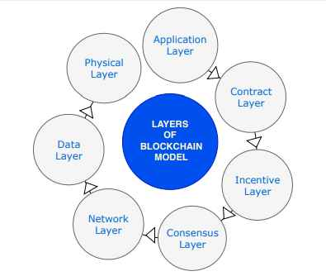

1. **Application Layer.**

This layer handles user skill verification, authentication of certificates provided by multiple institutes via blockchain networking, and storage of tokens in user wallets. This layer of the platform is responsible for the creation of the user experience that displays their profile along with (a) the certifications provided by the platform, (b) the coins in their wallet, and (c) the roles that they can take, such as instructor, candidate, evaluator, or recruiter.

1. **Contract Layer**

This layer primarily comprises numerous functional scripts that serve as a vital means of communication with the whole network, including blocks stored on the blockchain. This layer also implements the applications primary algorithm. The algorithm and functionality are encoded in a smart contract, which is a self-authenticating, self-administering, and self-driving quick-reaction rule system stored on the blockchain.

1. **Incentive Layer**

The incentive layer is intended to include prizes for participants (in our case, evaluators) to meet the goals of the blockchain network. EPBI and EPRM are desirable qualities for the application. These are obtained by awarding the assessment score ti to evaluator. Our network sends a certain quantity of tokens to evaluator i, which they can then exchange for fiat currency. However, we must verify that the platform does not incur a net loss as a result of such transfers. The platform makes tokens from payments made by (a) candidates who want to be certified, (b) recruiters who want to access the candidates' certificates, and (c) instructors who need to pay to give a course.

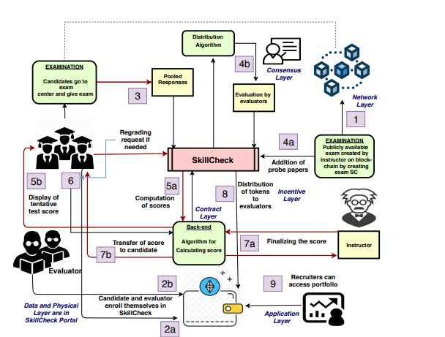

**Proficiency Reviewer**

**Data and physical layer**

Design Workflow

**1.5 Deliverables**

1. **Central Repository of Certificates**
2. **Specific Skill Assessment**
3. **Authenticity of Evaluators**
4. **Authenticity of Records**
5. **Increased Viewability for candidates**

*.*

**1.6 Blockchain Implementation**

To build a blockchain system, the Ethereum private network is used. Solidity was utilized to perform the primary functionality of a smart contract (SC).Every action in the Proficiency Reviewer platform, such as the instructor checking the probe papers, evaluators evaluating the answer scripts, candidates raising regrading requests, and the instructor assigning final skill and evaluation scores, is considered a transaction that is carried out via a cryptographically signed contract that runs on the network.

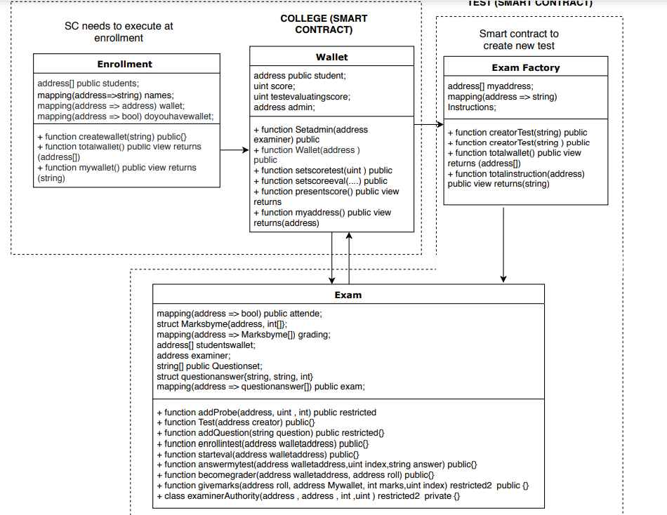

**1.7 Stakeholders**

1) Universities

2) Hiring platforms

3) Students

4) Corporate Organizations

**1.8 References**

* [1] Ali Alammary, Samah Alhazmi, Marwah Almasri, and Saira Gillani. Blockchain-based applications in education: A systematic review. Applied Sciences, 9(12):2400, 2019.
* [2] Anujit Chakraborty, Jatin Jindal, and Swaprava Nath. Incentivizing effort and precision in peer grading. arXiv preprint arXiv:1807.11657, 2020.
* [3] Bin Duan, Ying Zhong, and Dayu Liu. Education application of blockchain technology: Learning outcome and meta-diploma. In 2017 IEEE 23rd International Conference on Parallel and Distributed Systems (ICPADS), pages 814–817. IEEE, 2017.
* [4] Juan Carlos Farah, Andrii Vozniuk, Mar´ıa Jesus´ Rodr´ıguez-Triana, and Denis Gillet. A blueprint for a blockchain-based architecture to power a distributed network of tamper-evident learning trace repositories. In 2018 IEEE 18th International Conference on Advanced Learning Technologies (ICALT), pages 218–222. IEEE, 2018.
* [5] Eric Funk, Jeff Riddell, Felix Ankel, and Daniel Cabrera. Blockchain technology: a data framework to improve validity, trust, and accountability of information exchange in health professions education. Academic Medicine, 93 (12):1791–1794, 2018.
* [6] Alexander Grech and Anthony F Camilleri. Blockchain in education, 2017.
* [7] Jerinas Gresch, Bruno Rodrigues, Eder Scheid, Salil S Kanhere, and Burkhard Stiller. The proposal of a blockchain-based architecture for transparent certificate handling. In International Conference on Business Information Systems, pages 185–196. Springer, 2018.
* [8] Jay Gupta and Swaprava Nath. Skillcheck: An incentive-based certification system using blockchains. Technical report, IIT Kanpur, 2020.
* [9] David Lizcano, Juan A Lara, Bebo White, and Shadi Aljawarneh. Blockchain-based approach to create a model of trust in open and ubiquitous higher education. Journal of Computing in Higher Education, pages 1–26, 2019.
* [10] Alexander Mikroyannidis, John Domingue, Michelle Bachler, and Kevin Quick. Smart blockchain badges for data science education. In 2018 IEEE Frontiers in Education Conference (FIE), pages 1–5. IEEE, 2018.
* [11] Yong Yuan and Fei-Yue Wang. Towards blockchain based intelligent transportation systems. In 2016 IEEE 19th International Conference on Intelligent Transportation Systems (ITSC), pages 2663–2668. IEEE, 2016.